**Crop Yield Simulation for Illinois**

Contents

**1** **Objective** 2

**2** **Prerequisites:** 2

**3** **Hierarchy of the program** 3

**4** **Program inputs** 4

**5** **File Descriptions** 5

**5.1** **Run_all.m** 5

**5.2** **nWatch_main.m** 5

**5.3** **soil_with_id.m** 6

**5.4** **update_soil_wstation.m** 6

**5.5** **update_fertilizer.m** 6

**5.6** **get_index.m** 6

**5.7** **run_dssat_sim.m** 6

**5.8** **crop_yield.m** 6

# **Objective**

The purpose of this program is to estimate statewide crop yields in response to different crop management practices for cropping seasons between 2011 and 2015 in Illinois. The calibrated model is run for each soil data location from gSSURGO data for six hypothetical scenarios of N applications (0N, 150N, 200N, 150S, 200S, and 150SP) to obtain crop yield distributions across the entire state to understand relationships between N applications and precipitation on crop yields.

# **Prerequisites:**

1. DSSAT 4.6 installed on default directory, i.e. ‘C:\DSSAT46\’
2. Weather files (*.WTH) for 18 ISWS WARM weather stations are available for each station in ‘C:\DSSAT46\Weather’. The weather file format and explanation of variable are provided in the link:

<http://rsetserver.sws.uiuc.edu/docs/N%20Tracking%20Project/Weather%20Data/WEATHER%20DATA%20file%20format.docx>

Weather files for the eighteen sites are available on \\SWSATMOSSCI in ‘C:\DSSAT46\Weather\Illinois Stations’ with names *XXXX1006.WTH*, where XXXX is a four-letter code for each station. Notice that these files have weather data for 2010 to 2015, so will only work for simulations within these years. The code for each station is as follows:

* + - Brownstown 🡪 BRWN
    - Champaign/Urbana 🡪 CHMP
    - DeKalb 🡪 DEKL
    - Dixon Spring 🡪 DXSP
    - Monmouth 🡪 MONM
    - Perry 🡪 PERY
    - Belleville 🡪 BELL
    - Big Bend 🡪 BIGB
    - Bondville 🡪 BOND
    - Carbondale 🡪 CARB
    - Fairfield 🡪 FAIR
    - Freeport 🡪 FREP
    - Kilbourne 🡪 KILB
    - Peoria 🡪 PEOR
    - Rend Lake 🡪 RLAK
    - St. Charles 🡪 STCH
    - Springfield 🡪 SPRN
    - Stelle 🡪 STLE

**Notice** that this program is using 18 weather stations from ISWS WARM database. A similar simulation can be run for 2016 with NWS data but the weather file will have to be created manually (using weather module of ntrack program) for each location.

1. DSSAT input file templates (*.MZX) are available for each station in ‘C:\DSSAT46\Maize\’. These are the input files for DSSAT that are updated with new information before the simulations are run for each site. The format and help about FileX file and variables are provided in the following link:

<http://rsetserver.sws.uiuc.edu/docs/N%20Tracking%20Project/FileX%20format.docx>

The files for all six sites are available on \\SWSATMOSSCI in ‘C:\DSSAT46\Maize\ Illinois FileX\’ with names *UIXX1501.MZX*, where UI is the institute code and XX is a two-letter code for each station as described below:

* + - Brownstown 🡪 BR
    - Champaign/Urbana 🡪 UB
    - DeKalb 🡪 DK
    - Dixon Spring 🡪 DX
    - Monmouth 🡪 MO
    - Perry 🡪 PE

Copy the files from ‘Illinois FileX’ folder to the ‘C:\DSSAT46\Maize\’ before using the program.

# **Hierarchy of the program**

The following is the hierarchy of the program. Indentation indicates the levels, meaning that the function is being called by another function with one less level.

* Run_all.m
* nWatch_main.m
  + soil_with_id.m
  + update_soil_wstation.m
  + update_fertilizer.m
    - get_index.m
  + run_dssat_sim.m
  + crop_yield.m
    - get_index.m

The source code of the program can be found on \\SWSATMOSSCI in the directory ‘C:\Users\Administrator\Documents\MATLAB\nTrack_5000’

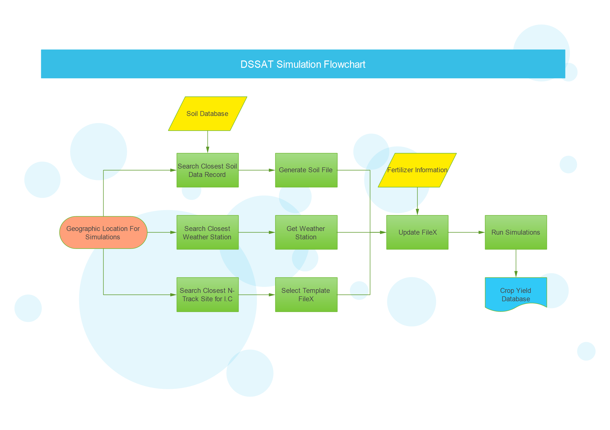

**Figure 1: Program flowchart**

# **Program inputs**

The program takes two inputs: one for gSSURGO soil file (‘IL_Soil_Data_Base_Das.txt’) location which is located on \\SWSATMOSSCI in the directory 'H:\SunY\Soildata\ ', and an excel file with location ids and geographic coordinates as shown in the figure below. Update the soil file and the excel locations files path in the program before running the main file.

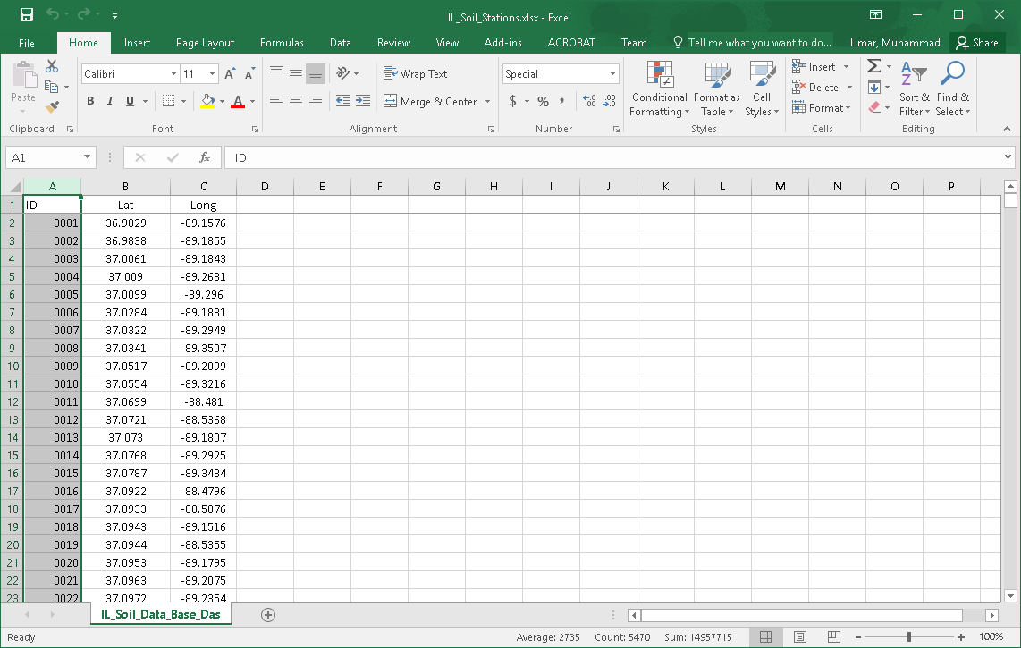

In addition, user can modify the kinds of fertilizer treatments on line 10. Currently, the program is set to run for six treatments (0N, 150N, 200N, 150S, 200S, 150SP) for two year 2011, and 2012 (line 13). The user may run the program for any treatment (out of these six) and any year between 2011 and 2015.

# **File Descriptions**

## **Run_all.m**

This file is the main entry point to the program. The program can be run for up to six treatments (0N, 150N, 200N, 150S, 200S, 150SP) and for five years between 2011 and 2015. For each N treatment and each year, total number of simulations is determined by the number of records in the excel file that contains geographic locations. Types of treatments and number of years can be modified as desired.

## **nWatch_main.m**

For each treatment type and each year, this function is called to run the simulations for all the sites in the input excel file. For each location, the function calls soil_with_id.m to generates a soil file for the current location and searches for nearest ISWS weather station (18 stations in total), to identify the weather file o be used in the program. For initial conditions, the program uses six N track sites and uses the site FileX (DSSAT input file) as input file for the location which is closest.

## **soil_with_id.m**

Generates a soil file corresponding to the input geographic location

## **update_soil_wstation.m**

The role of this function is to add weather station info, soil ID, and latitude, longitude information to the FileX.

## **update_fertilizer.m**

This function takes in the fertilizer treatment type and the year for which the simulations are running to define fertilizer amounts and fertilizer application dates which are then used to update the FileX. For example, 0N means 0-nitrogen application while 200N means 200lbs/acre nitrogen application in Fall. In addition, the function also updates planting and simulation start dates, such that;

* Planting date: May, 01 of the simulation year
* Simulation start date: November 1st of previous year

Harvest date is set at when crop matures

## **get_index.m**

Given a pattern and a text, the function return the index where the pattern is match

## **run_dssat_sim.m**

Using the updates FileX, the function executes the DSSAT exe to run simulation for the current scenario.

## **crop_yield.m**

From the output files generated by DSSAT simulations, the function reads the OVERVIEW.OUT file and return the crop yield from the current simulations.

Finally, the program writes a csv file with four columns: 1) Site ID, 2) Latitude, 3) Longitude, and 4) Crop yield and writes this information to a csv file with a name in format yyyy_treatmen.csv. For example, 2011_200S.csv. Notice that one file is generated for a treatment type and year, therefore each csv file has number of data records equal to the input excel file for simulation locations.